**No** CDS Annotations APP – End to End:

1. Tables and CDS Views (Not necessary to use CDS if not possible):

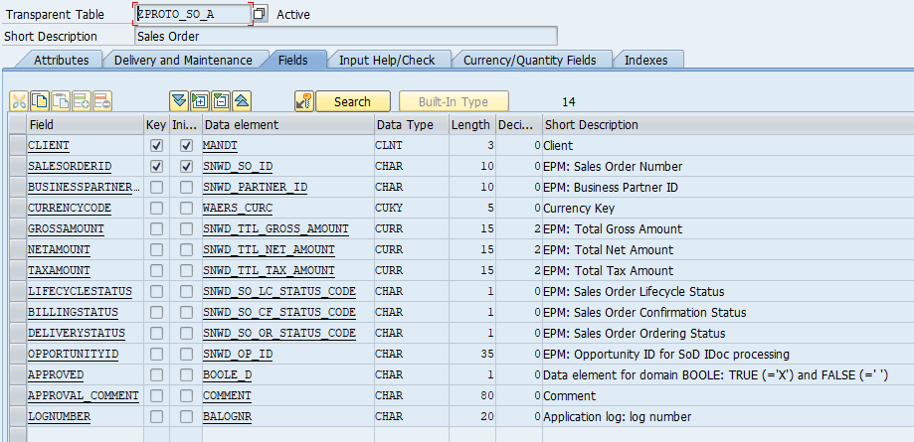  
  
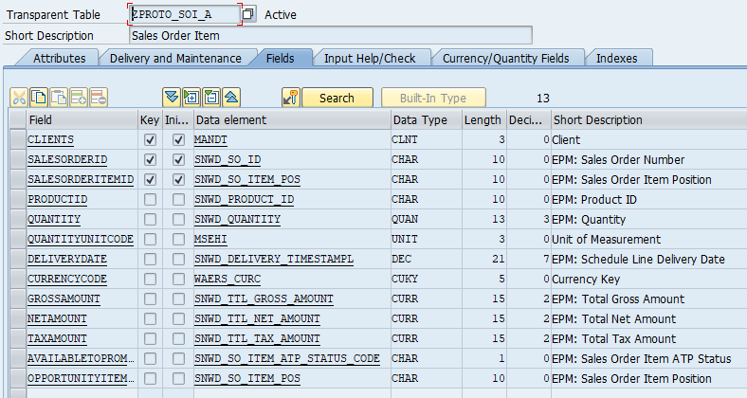

@AbapCatalog.sqlViewName: 'ZDDL_I_ZPROTOSO'

@AbapCatalog.compiler.compareFilter: true

@AbapCatalog.preserveKey: true

@AccessControl.authorizationCheck: #NOT_REQUIRED

@Search.searchable: true

@EndUserText.label: 'CDS View for ZPROTO_SO_A BASIC'

**define** **view** ZDDL_I_ZPROTO_SO_A

**as** **select** **from** zproto_so_a **as** SalesOrder

**association** **[**1**..*]** **to** ZDDL_I_ZPROTO_SOI_A **as** _Item

**on** **$projection.**SalesOrderID **=** _Item**.**SalesOrderID

**{**

//SalesOrder

@Search.defaultSearchElement: true

**key** salesorderid **as** SalesOrderID**,**

@Search.defaultSearchElement: true

businesspartnerid **as** BusinessPartnerID**,**

currencycode **as** CurrencyCode**,**

grossamount **as** GrossAmount**,**

netamount **as** NetAmount**,**

taxamount **as** TaxAmount**,**

lifecyclestatus **as** LifeCycleStatus**,**

// Associations/Navigation

_Item

**}**

@AbapCatalog.sqlViewName: 'ZDDL_I_ZPROTOSOI'

@AbapCatalog.compiler.compareFilter: true

@AccessControl.authorizationCheck: #NOT_REQUIRED

@EndUserText.label: 'CDS View for ZPROTO_SO_A'

@Search.searchable: true

**define** **view** ZDDL_I_ZPROTO_SOI_A

**as** **select** **from** zproto_soi_a **as** Item

//Association to header

**association** **[**1**..**1**]** **to** ZDDL_I_ZPROTO_SO_A **as** _SalesOrder

**on** **$projection.**SalesOrderID **=** _SalesOrder**.**SalesOrderID

**{**

//Item

@Search.defaultSearchElement: true

@ObjectModel.readOnly: true

**key** salesorderid **as** SalesOrderID**,**

@Search.defaultSearchElement: true

**key** salesorderitemid **as** SalesOrderItemID**,**

@Search.defaultSearchElement: true

productid **as** ProductID**,**

quantity **as** Quantity**,**

quantityunitcode **as** QuantityUnitCode**,**

deliverydate **as** DeliveryDate**,**

currencycode **as** CurrencyCode**,**

grossamount **as** GrossAmount**,**

netamount **as** NetAmount**,**

taxamount **as** TaxAmount**,**

//Association to SO Order

_SalesOrder

**}**

1. OData Service
   1. Entity Types



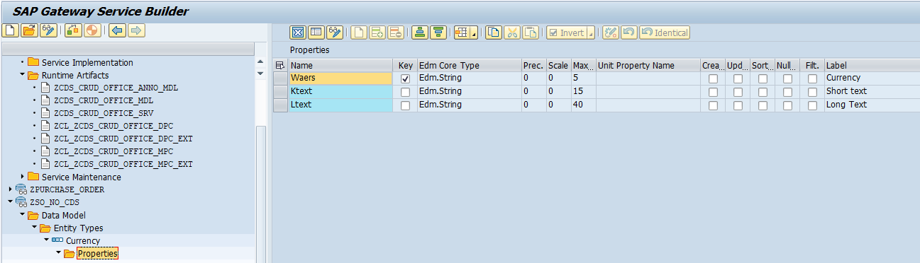  
  


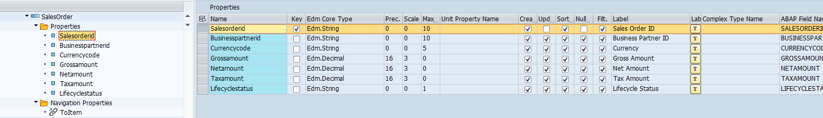



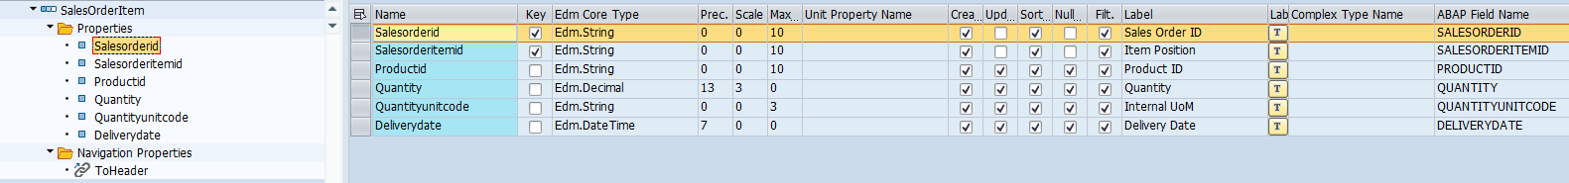



* 1. Associations  
       
     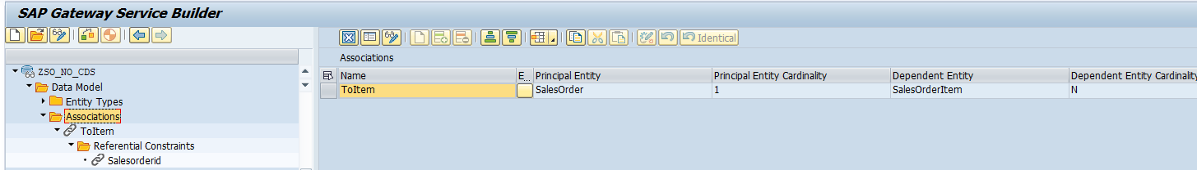



* 1. Entity Set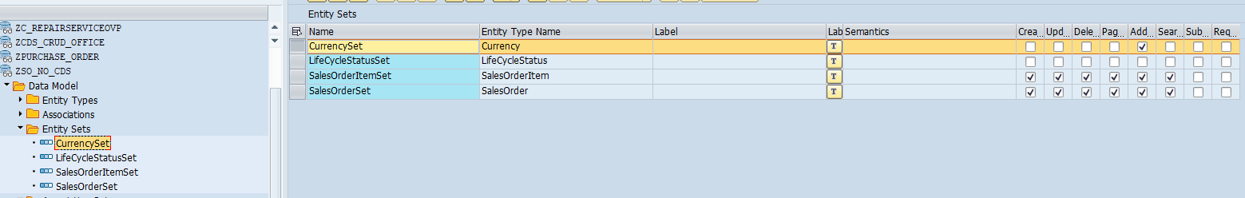
  2. Associations Set  
       
     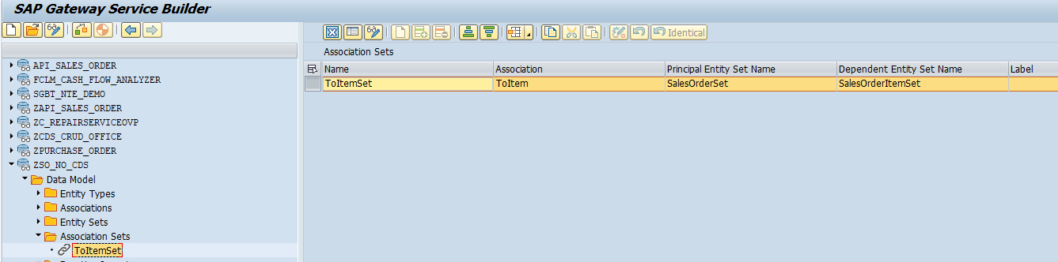
  3. Function Imports

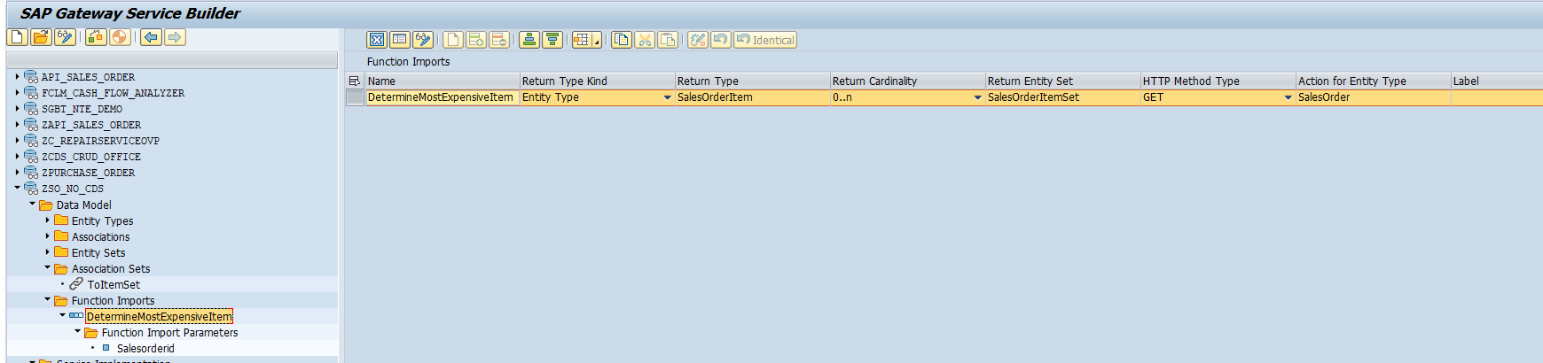

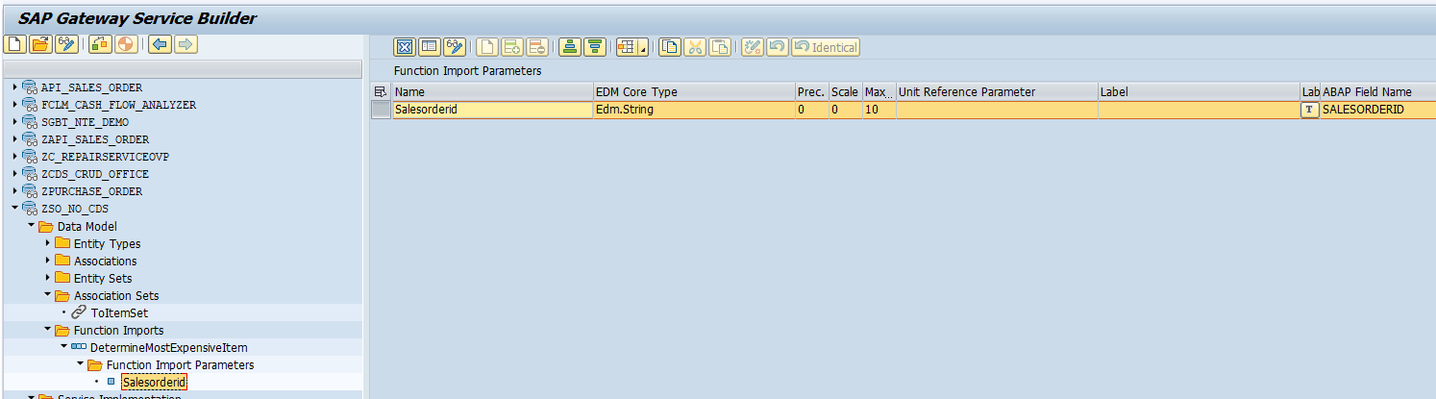

* 1. Run Artifacts ( DPC_EXT Class )

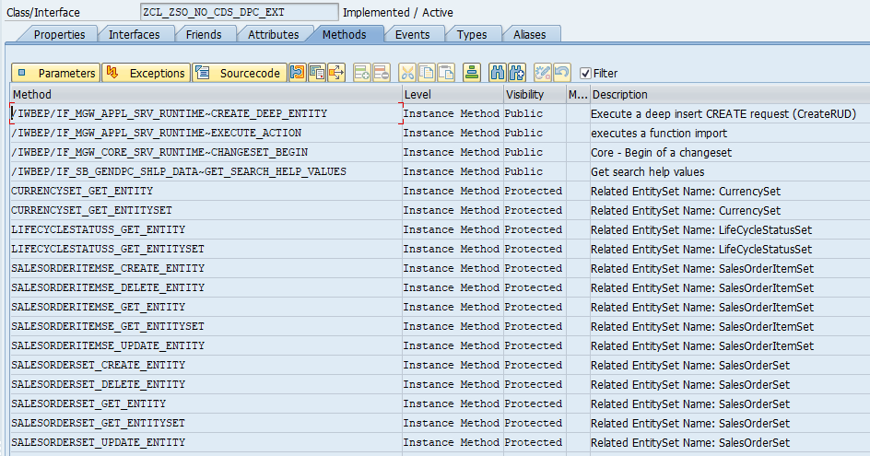

METHOD /iwbep/if_mgw_appl_srv_runtime~create_deep_entity.  
  
  DATA: BEGIN OF ls_order_item_data.  
      INCLUDE TYPE zcl_zso_no_cds_mpc=>ts_salesorder.  
  DATA: toitem TYPE zcl_zso_no_cds_mpc=>tt_salesorderitem,  
        END OF ls_order_item_data.  
  
  
  DATA: ls_so_db  TYPE zproto_so_a,  
        lt_soi_db TYPE TABLE OF zproto_soi_a,  
        ls_soi_db TYPE zproto_soi_a.  
  
  DATA(lv_entityset) = io_tech_request_context->get_entity_set_name( ).  
  
  CASE lv_entityset.  
    WHEN 'SalesOrderSet'.  
  
      io_data_provider->read_entry_data(  
        IMPORTING  
          es_data = ls_order_item_data ).  
  
      IF ls_order_item_data-salesorderid IS INITIAL.  
        "Ideale wäre mit SNRO transaktion machen  
        SELECT COUNT(*)  
          INTO @DATA(lv_count)  
          FROM zddl_i_zproto_so_a.  
        IF sy-subrc = 0.  
          ls_order_item_data-salesorderid = lv_count + 1.  
        ELSE.  
          ls_order_item_data-salesorderid = 1.  
        ENDIF.  
        ls_order_item_data-salesorderid = |{ ls_order_item_data-salesorderid ALPHA = IN }|.  
      ENDIF.  
  
      ls_so_db  = CORRESPONDING #( ls_order_item_data ).  
  
      INSERT zproto_so_a FROM ls_so_db.  
      IF sy-subrc <> 0.  
        ROLLBACK WORK.  
  
        DATA(lo_message_container) = /iwbep/if_mgw_conv_srv_runtime~get_message_container( ).  
        "Duplicated KEY - Not allowed  
        lo_message_container->add_message(  
          EXPORTING  
            iv_msg_type               = 'E'  
            iv_msg_id                 = 'ZIMU'  
            iv_msg_number             =  004  ).  
  
        RAISE EXCEPTION TYPE /iwbep/cx_mgw_busi_exception  
          EXPORTING  
            message_container = lo_message_container.  
  
      ENDIF.  
      " Insert ITEMS  
      LOOP AT ls_order_item_data-toitem ASSIGNING FIELD-SYMBOL(<fs_item>).  
        DATA(lv_tabix) = sy-tabix.  
        <fs_item>-salesorderid = ls_order_item_data-salesorderid.  
  
        IF <fs_item>-salesorderitemid IS INITIAL.  
          <fs_item>-salesorderitemid = lv_tabix * 1000.  
          <fs_item>-salesorderitemid = |{ <fs_item>-salesorderitemid ALPHA = IN }|.  
        ENDIF.  
  
        ls_soi_db = CORRESPONDING #( <fs_item> ).  
        INSERT ls_soi_db INTO TABLE lt_soi_db.  
        CLEAR ls_soi_db.  
      ENDLOOP.  
  
      INSERT zproto_soi_a FROM TABLE lt_soi_db.  
      IF sy-subrc <> 0.  
        ROLLBACK WORK.  
  
        lo_message_container = /iwbep/if_mgw_conv_srv_runtime~get_message_container( ).  
        "Duplicated KEY - Not allowed  
        lo_message_container->add_message(  
          EXPORTING  
            iv_msg_type               = 'E'  
            iv_msg_id                 = 'ZIMU'  
            iv_msg_number             =  004  ).  
  
        RAISE EXCEPTION TYPE /iwbep/cx_mgw_busi_exception  
          EXPORTING  
            message_container = lo_message_container.  
  
      ENDIF.  
  
      copy_data_to_ref(  
        EXPORTING  
          is_data = ls_order_item_data  
        CHANGING  
          cr_data = er_deep_entity  ).  
  
    WHEN OTHERS.  
  ENDCASE.  
  
ENDMETHOD.

METHOD /iwbep/if_mgw_appl_srv_runtime~execute_action.  
  
  DATA: ls_so  TYPE zcl_zso_no_cds_mpc_ext=>ts_salesorder,  
        lt_soi TYPE TABLE OF zcl_zso_no_cds_mpc_ext=>ts_salesorderitem,  
        ls_soi TYPE zcl_zso_no_cds_mpc_ext=>ts_salesorderitem.  
  
  DATA(lv_action) = io_tech_request_context->get_function_import_name( ).  
  
  CASE lv_action.  
    WHEN 'DetermineMostExpensiveItem'.  
  
      io_tech_request_context->get_converted_parameters(  
        IMPORTING  
          es_parameter_values = ls_so  ).  
  
      ls_so-salesorderid = |{ ls_so-salesorderid ALPHA = IN }|.  
  
      SELECT *  
        FROM zddl_i_zproto_soi_a  
        INTO TABLE @DATA(lt_zddl_i_zproto_soi_a)  
        WHERE salesorderid = @ls_so-salesorderid ORDER BY grossamount DESCENDING.  
      IF sy-subrc = 0.  
        READ TABLE lt_zddl_i_zproto_soi_a INTO DATA(ls_item) INDEX 1.  
  
        ls_soi = CORRESPONDING #( ls_item ).  
  
        "Format TimeStamp  
        DATA: lv_tstm TYPE cest1-timestmp,  
              lv_date TYPE sy-datum,  
              lv_time TYPE sy-uzeit.  
  
        IF ls_soi-deliverydate IS NOT INITIAL.  
  
          lv_tstm = ls_soi-deliverydate.  
  
          CALL FUNCTION 'RKE_TIMESTAMP_CONVERT_OUTPUT'  
            EXPORTING  
              i_dayst    = sy-dayst  
              i_timestmp = lv_tstm  
              i_tzone    = sy-tzone  
            IMPORTING  
              e_date     = lv_date  
              e_time     = lv_time.  
  
          ls_soi-deliverydate = lv_date && lv_time.  
  
        ENDIF.  
  
        INSERT ls_soi INTO TABLE lt_soi.  
  
        copy_data_to_ref(  
          EXPORTING  
            is_data = lt_soi  
          CHANGING  
            cr_data = er_data ).  
  
      ELSE.  
        RAISE EXCEPTION TYPE /IWBEP/CX_MGW_BUSI_EXCEPTION.  
      ENDIF.  
  
    WHEN OTHERS.  
  ENDCASE.  
  
ENDMETHOD.

METHOD /iwbep/if_mgw_core_srv_runtime~changeset_begin.  
  
  TRY.  
      CALL METHOD super->/iwbep/if_mgw_core_srv_runtime~changeset_begin  
        EXPORTING  
          it_operation_info  = it_operation_info  
          it_changeset_input = it_changeset_input  
        CHANGING  
          cv_defer_mode      = cv_defer_mode.  
    CATCH /iwbep/cx_mgw_busi_exception /iwbep/cx_mgw_tech_exception.  
  
      "Updating more than 2 entries ?  
  
  ENDTRY.  
  
  
  
ENDMETHOD.

method CURRENCYSET_GET_ENTITY.  
  
  DATA: lt_curr  TYPE zcl_zso_no_cds_mpc=>tt_currency,  
        ls_curr  TYPE LINE OF zcl_zso_no_cds_mpc=>tt_currency,  
        lr_curr  TYPE RANGE OF waers_curc,  
        ls_cur   LIKE LINE OF lr_curr.  
  
  LOOP AT it_key_tab INTO DATA(ls_key_tab).  
  
    CASE ls_key_tab-name.  
      WHEN 'Currency'.  
        ls_cur-sign   = 'I'.  
        ls_cur-option = 'EQ'.  
        ls_cur-low    = ls_key_tab-value.  
        CONDENSE ls_cur-low.  
        INSERT ls_cur INTO TABLE lr_curr.  
      WHEN OTHERS.  
    ENDCASE.  
  
  ENDLOOP.  
  
  SELECT SINGLE a~waers, b~ktext , b~ltext  
    INTO @ls_curr  
    FROM tcurc AS a  
    INNER JOIN tcurt AS b ON ( a~waers = b~waers )  
    WHERE a~waers IN @lr_curr  
      AND b~spras EQ @sy-langu.  
  IF sy-subrc = 0.  
    er_entity = ls_curr.  
  ENDIF.  
  
endmethod.

METHOD currencyset_get_entityset.  
  
  DATA: lt_curr TYPE zcl_zso_no_cds_mpc=>tt_currency,  
        ls_curr TYPE LINE OF zcl_zso_no_cds_mpc=>tt_currency,  
        lr_curr TYPE RANGE OF waers_curc,  
        ls_cur  LIKE LINE OF lr_curr,  
        lt_sh   TYPE ddshselops,  
        ls_sh   TYPE LINE OF ddshselops.  
  
  
  DATA(lr_filter) = io_tech_request_context->get_filter( ).  
  IF lr_filter IS BOUND.  
    DATA(lt_filter_so) = lr_filter->get_filter_select_options( ).  
  ENDIF.  
  
  IF lt_filter_so IS NOT INITIAL.  
  
    LOOP AT lt_filter_so ASSIGNING FIELD-SYMBOL(<fs_filter_so>).  
      ls_sh-shlpname  = 'FC_WAERS'.  
      ls_sh-shlpfield = <fs_filter_so>-property.  
      LOOP AT <fs_filter_so>-select_options ASSIGNING FIELD-SYMBOL(<fs_so>).  
        ls_sh-sign   = <fs_so>-sign.  
        ls_sh-low    = <fs_so>-low.  
        ls_sh-high   = <fs_so>-high.  
        ls_sh-option = <fs_so>-option.  
        INSERT ls_sh INTO TABLE lt_sh.  
        CLEAR: ls_sh-sign, ls_sh-low, ls_sh-high, ls_sh-option.  
      ENDLOOP.  
    ENDLOOP.  
  
    me->/iwbep/if_sb_gendpc_shlp_data~get_search_help_values( EXPORTING iv_shlp_name   = 'FC_WAERS'  
                                                                        it_selopt      = lt_sh  
                                                              IMPORTING et_return_list = DATA(lt_filter) ).  
  
    LOOP AT lt_filter ASSIGNING FIELD-SYMBOL(<fs_filter>).  
      CASE <fs_filter>-field_name.  
        WHEN 'WAERS'.  
          ls_curr-waers = <fs_filter>-field_value.  
        WHEN 'KTEXT'.  
          ls_curr-ktext = <fs_filter>-field_value.  
        WHEN 'LTEXT'.  
          ls_curr-ltext = <fs_filter>-field_value.  
        WHEN OTHERS.  
      ENDCASE.  
  
      AT END OF record_number.  
        INSERT ls_curr INTO TABLE lt_curr.  
      ENDAT.  
    ENDLOOP.  
  
    et_entityset = lt_curr.  
  
  ELSE.  
  
    LOOP AT it_key_tab INTO DATA(ls_key_tab).  
  
      CASE ls_key_tab-name.  
        WHEN 'Currency'.  
          ls_cur-sign   = 'I'.  
          ls_cur-option = 'EQ'.  
          ls_cur-low    = ls_key_tab-value.  
          CONDENSE ls_cur-low.  
          INSERT ls_cur INTO TABLE lr_curr.  
        WHEN OTHERS.  
      ENDCASE.  
  
    ENDLOOP.  
  
    SELECT a~waers, b~ktext , b~ltext  
      INTO TABLE @lt_curr  
      FROM tcurc AS a  
      INNER JOIN tcurt AS b ON ( a~waers = b~waers )  
      WHERE a~waers IN @lr_curr  
        AND b~spras EQ @sy-langu.  
    IF sy-subrc = 0.  
      et_entityset = lt_curr.  
    ENDIF.  
  
  ENDIF.  
  
ENDMETHOD.

METHOD lifecyclestatuss_get_entity.  
  
  DATA: lv_so    TYPE zddl_i_zproto_so_a-salesorderid,  
        lt_dd07v TYPE TABLE OF dd07v.  
  
  READ TABLE it_key_tab INTO DATA(ls_key) WITH KEY name = 'Salesorderid'.  
  IF sy-subrc = 0.  
    lv_so = |{ ls_key-value ALPHA = IN }|.  
  ENDIF.  
  
  SELECT SINGLE *  
    FROM zddl_i_zproto_so_a  
    INTO @DATA(ls_so_db)  
    WHERE salesorderid = @lv_so.  
  
  IF sy-subrc = 0.  
  
    CALL FUNCTION 'DD_DOMVALUES_GET'  
      EXPORTING  
        domname        = 'D_SO_LC'  
        text           = 'X'  
        langu          = sy-langu  
      TABLES  
        dd07v_tab      = lt_dd07v  
      EXCEPTIONS  
        wrong_textflag = 1  
        OTHERS         = 2.  
  
    READ TABLE lt_dd07v INTO DATA(ls_dd07v) WITH KEY domvalue_l = ls_so_db-lifecyclestatus.  
    IF sy-subrc = 0.  
      er_entity-lifecyclestatus     = ls_dd07v-domvalue_l.  
      er_entity-lifecyclestatustext = ls_dd07v-ddtext.  
    ENDIF.  
  
  ENDIF.  
  
ENDMETHOD.

METHOD lifecyclestatuss_get_entityset.  
  
  DATA: lt_life  TYPE zcl_zso_no_cds_mpc=>tt_lifecyclestatus,  
        lt_dd07v TYPE TABLE OF dd07v,  
        ls_life  TYPE LINE OF zcl_zso_no_cds_mpc=>tt_lifecyclestatus.  
  
  CALL FUNCTION 'DD_DOMVALUES_GET'  
    EXPORTING  
      domname        = 'D_SO_LC'  
      text           = 'X'  
      langu          = sy-langu  
    TABLES  
      dd07v_tab      = lt_dd07v  
    EXCEPTIONS  
      wrong_textflag = 1  
      OTHERS         = 2.  
  
  LOOP AT lt_dd07v ASSIGNING FIELD-SYMBOL(<fs_dd07v>).  
    ls_life-lifecyclestatus     = <fs_dd07v>-domvalue_l.  
    ls_life-lifecyclestatustext = <fs_dd07v>-ddtext.  
    INSERT ls_life INTO TABLE lt_life.  
  ENDLOOP.  
  
  ET_ENTITYSET = lt_life.  
  
ENDMETHOD.

METHOD salesorderitemse_create_entity.  
  
  DATA: ls_so    TYPE zcl_zso_no_cds_mpc=>ts_salesorderitem,  
        ls_so_db TYPE zproto_soi_a.  
  
  io_data_provider->read_entry_data(  
    IMPORTING  
      es_data = ls_so ).  
  
  "It is creating a new Item on the UI  
  READ TABLE it_key_tab INTO DATA(ls_key) WITH KEY name = 'Salesorderid'.  
  IF sy-subrc = 0 AND ls_so-salesorderid IS INITIAL.  
    ls_so-salesorderid = ls_key-value.  
    ls_so-salesorderid = |{ ls_so-salesorderid  ALPHA = IN }|.  
  ENDIF.  
  
  SELECT SINGLE salesorderid  
         FROM zddl_i_zproto_so_a  
         INTO @DATA(lv_so_id)  
         WHERE salesorderid = @ls_so-salesorderid.  
  IF sy-subrc <> 0.  
    mo_context->get_message_container( )->add_message_text_only(  
      EXPORTING  
        iv_msg_type               = 'E'  
        iv_msg_text               = 'Create Header First' ).  
  
    RAISE EXCEPTION TYPE /iwbep/cx_mgw_busi_exception.  
  
  ELSE.  
    "Calculate next item  
    SELECT salesorderid, salesorderitemid  
      FROM zddl_i_zproto_soi_a  
      INTO TABLE @DATA(lt_items)  
      WHERE salesorderid = @ls_so-salesorderid ORDER BY salesorderitemid DESCENDING.  
    IF sy-subrc = 0.  
      READ TABLE lt_items ASSIGNING FIELD-SYMBOL(<fs_item>) INDEX 1.  
      IF sy-subrc = 0.  
        ls_so-salesorderitemid = <fs_item>-salesorderitemid + 1000.  
        ls_so-salesorderitemid = |{ ls_so-salesorderitemid  ALPHA = IN }|.  
      ENDIF.  
    ELSE. " First Item  
      ls_so-salesorderitemid = 1000.  
      ls_so-salesorderitemid = |{ ls_so-salesorderitemid  ALPHA = IN }|.  
    ENDIF.  
  ENDIF.  
  
  ls_so_db  = CORRESPONDING #( ls_so ).  
  
  INSERT zproto_soi_a FROM ls_so_db.  
  IF sy-subrc <> 0.  
  
    DATA(lo_message_container) = /iwbep/if_mgw_conv_srv_runtime~get_message_container( ).  
    "Duplicated Key  
    lo_message_container->add_message(  
      EXPORTING  
        iv_msg_type               = 'E'  
        iv_msg_id                 = 'ZIMU'  
        iv_msg_number             =  004  ).  
  
    RAISE EXCEPTION TYPE /iwbep/cx_mgw_busi_exception  
      EXPORTING  
        message_container = lo_message_container.  
  
  ENDIF.  
  
  er_entity = CORRESPONDING #( ls_so ).  
  
ENDMETHOD.

METHOD salesorderitemse_delete_entity.  
  
  DATA: ls_so TYPE zcl_zso_no_cds_mpc=>ts_salesorderitem.  
  
  io_tech_request_context->get_converted_keys(  
    IMPORTING  
      es_key_values = ls_so ).  
  
  SELECT COUNT(*)  
     FROM zproto_soi_a  
     INTO @DATA(lv_items)  
     WHERE salesorderid     = @ls_so-salesorderid.  
  
  " Update the table rather than the CDS view itself.  
  DELETE FROM zproto_soi_a WHERE salesorderid     = ls_so-salesorderid  
                             AND salesorderitemid = ls_so-salesorderitemid.  
  IF sy-subrc <> 0.  
  
    DATA(lo_message_container) = /iwbep/if_mgw_conv_srv_runtime~get_message_container( ).  
    "Data does not exist.  
    lo_message_container->add_message(  
      EXPORTING  
        iv_msg_type               = 'E'  
        iv_msg_id                 = 'ZIMU'  
        iv_msg_number             =  005  ).  
  
    RAISE EXCEPTION TYPE /iwbep/cx_mgw_busi_exception  
      EXPORTING  
        message_container = lo_message_container.  
  
  ENDIF.  
  
  
ENDMETHOD.

METHOD salesorderitemse_get_entity.  
  
  DATA: ls_soi TYPE zddl_i_zproto_soi_a.  
  
  io_tech_request_context->get_converted_keys(  
    IMPORTING  
      es_key_values = ls_soi " Entity Key Values - converted  
  ).  
  
  SELECT SINGLE salesorderid, salesorderitemid, productid, quantity, quantityunitcode, deliverydate  
    FROM zddl_i_zproto_soi_a  
    INTO @DATA(ls_soi_db)  
    WHERE salesorderid EQ @ls_soi-salesorderid  
      AND salesorderitemid EQ @ls_soi-salesorderitemid.  
  
  IF sy-subrc = 0.  
  
    er_entity = CORRESPONDING #( ls_soi_db ).  
  
    "Format TimeStamp  
    DATA: lv_tstm TYPE cest1-timestmp,  
          lv_date TYPE sy-datum,  
          lv_time TYPE sy-uzeit.  
  
    IF er_entity-deliverydate IS NOT INITIAL.  
  
      lv_tstm = er_entity-deliverydate.  
  
      CALL FUNCTION 'RKE_TIMESTAMP_CONVERT_OUTPUT'  
        EXPORTING  
          i_dayst    = sy-dayst  
          i_timestmp = lv_tstm  
          i_tzone    = sy-tzone  
        IMPORTING  
          e_date     = lv_date  
          e_time     = lv_time.  
  
      er_entity-deliverydate = lv_date && lv_time.  
  
    ENDIF.  
  
  ELSE.  
    DATA(lo_message_container) = /iwbep/if_mgw_conv_srv_runtime~get_message_container( ).  
    "No Data Found  
    lo_message_container->add_message(  
      EXPORTING  
        iv_msg_type               = 'E'  
        iv_msg_id                 = 'ZIMU'  
        iv_msg_number             =  003  ).  
  
    RAISE EXCEPTION TYPE /iwbep/cx_mgw_busi_exception  
      EXPORTING  
        message_container = lo_message_container.  
  ENDIF.  
ENDMETHOD.

METHOD salesorderitemse_get_entityset.  
  
  TYPES: ty_salesorderid     TYPE RANGE OF zddl_i_zproto_soi_a-salesorderid,  
         ty_salesorderitemid TYPE RANGE OF zddl_i_zproto_soi_a-salesorderitemid,  
         ty_productid        TYPE RANGE OF zddl_i_zproto_soi_a-productid,  
         ty_quantity         TYPE RANGE OF zddl_i_zproto_soi_a-quantity,  
         ty_quantityunitcode TYPE RANGE OF zddl_i_zproto_soi_a-quantityunitcode,  
         ty_deliverydate     TYPE RANGE OF zddl_i_zproto_soi_a-deliverydate.  
  
  DATA: lr_salesorderid     TYPE ty_salesorderid,  
        lr_salesorderitemid TYPE ty_salesorderitemid,  
        lr_productid        TYPE ty_productid,  
        lr_quantity         TYPE ty_quantity,  
        lr_quantityunitcode TYPE ty_quantityunitcode,  
        lr_deliverydate     TYPE ty_deliverydate.  
  
  DATA: lt_sort TYPE abap_sortorder_tab,  
        ls_sort TYPE LINE OF abap_sortorder_tab.  
  
  DATA(lr_filter) = io_tech_request_context->get_filter( ).  
  IF lr_filter IS BOUND.  
    DATA(lt_filter_so) = lr_filter->get_filter_select_options( ).  
  ENDIF.  
  
  "URI Filter <> $filter  
  LOOP AT it_key_tab INTO DATA(ls_key_tab).  
  
    TRANSLATE ls_key_tab-name TO UPPER CASE.  
  
    CASE ls_key_tab-name.  
      WHEN 'SALESORDERID'.  
        lr_salesorderid[]      = VALUE ty_salesorderid( ( sign = 'I' option = 'EQ' low = ls_key_tab-value ) ).  
        LOOP AT lr_salesorderid ASSIGNING FIELD-SYMBOL(<fs_so>).  
          <fs_so>-low  =  |{ <fs_so>-low  ALPHA = IN }|.  
          <fs_so>-high =  |{ <fs_so>-high ALPHA = IN }|.  
        ENDLOOP.  
      WHEN 'SALESORDERITEMID'.  
        lr_salesorderitemid[] = VALUE ty_salesorderitemid( ( sign = 'I' option = 'EQ' low = ls_key_tab-value ) ).  
      WHEN 'PRODUCTID'.  
        lr_productid[]        = VALUE ty_productid( ( sign = 'I' option = 'EQ' low = ls_key_tab-value ) ).  
      WHEN 'QUANTITY'.  
        lr_quantity[]         = VALUE ty_quantity( ( sign = 'I' option = 'EQ' low = ls_key_tab-value ) ).  
      WHEN 'QUANTITYUNITCODE'.  
        lr_quantityunitcode[] = VALUE ty_quantityunitcode( ( sign = 'I' option = 'EQ' low = ls_key_tab-value ) ).  
      WHEN 'DELIVERYDATE'.  
        lr_deliverydate[]     = VALUE ty_deliverydate( ( sign = 'I' option = 'EQ' low = ls_key_tab-value ) ).  
      WHEN OTHERS.  
    ENDCASE.  
  
  ENDLOOP.  
  
  "This is useful for dynamic queries. $filter  
  DATA(lv_sql) = io_tech_request_context->get_osql_where_clause_convert( ).  
  DATA(lv_sql2) = io_tech_request_context->get_osql_where_clause( ).  
  
  " $filter  
  LOOP AT lt_filter_so REFERENCE INTO DATA(lr_filter_so).  
    CASE lr_filter_so->property.  
      WHEN 'SALESORDERID'.  
        lr_salesorderid[]      = CORRESPONDING #( lr_filter_so->select_options ).  
        LOOP AT lr_salesorderid ASSIGNING <fs_so>.  
          <fs_so>-low  =  |{ <fs_so>-low  ALPHA = IN }|.  
          <fs_so>-high =  |{ <fs_so>-high ALPHA = IN }|.  
        ENDLOOP.  
      WHEN 'SALESORDERITEMID'.  
        lr_salesorderitemid[] = CORRESPONDING #( lr_filter_so->select_options ).  
      WHEN 'PRODUCTID'.  
        lr_productid[]        = CORRESPONDING #( lr_filter_so->select_options ).  
      WHEN 'QUANTITY'.  
        lr_quantity[]         = CORRESPONDING #( lr_filter_so->select_options ).  
      WHEN 'QUANTITYUNITCODE'.  
        lr_quantityunitcode[] = CORRESPONDING #( lr_filter_so->select_options ).  
      WHEN 'DELIVERYDATE'.  
        lr_deliverydate[]     = CORRESPONDING #( lr_filter_so->select_options ).  
      WHEN OTHERS.  
    ENDCASE.  
  ENDLOOP.  
  
  SELECT salesorderid, salesorderitemid, productid, quantity, quantityunitcode, deliverydate  
    FROM zddl_i_zproto_soi_a  
    INTO TABLE @DATA(lt_so)  
    WHERE salesorderid     IN @lr_salesorderid  
      AND salesorderitemid IN @lr_salesorderitemid  
      AND productid        IN @lr_productid  
      AND quantity         IN @lr_quantity  
      AND quantityunitcode IN @lr_quantityunitcode  
      AND deliverydate     IN @lr_deliverydate.  
  
  IF sy-subrc = 0.  
  
    " $orderby  
    DATA(lt_orderby) = io_tech_request_context->get_orderby( ).  
    LOOP AT lt_orderby INTO DATA(ls_orderby).  
      ls_sort-name = ls_orderby-property.  
      IF ls_orderby-order = 'desc'.  
        ls_sort-descending = abap_true.  
      ENDIF.  
      INSERT ls_sort INTO TABLE lt_sort.  
      CLEAR ls_sort.  
    ENDLOOP.  
  
    SORT lt_so BY (lt_sort).  
  
    " $inlinecount  
    IF io_tech_request_context->has_inlinecount( ).  
      es_response_context-inlinecount = lines( lt_so ).  
    ENDIF.  
    " $skip  
    IF is_paging-skip IS NOT INITIAL.  
      DO is_paging-skip TIMES.  
        DELETE lt_so[] INDEX 1.  
      ENDDO.  
    ENDIF.  
    " $top  
    IF is_paging-top IS NOT INITIAL.  
      LOOP AT lt_so INTO DATA(ls_so).  
        IF sy-tabix > is_paging-top.  
          DELETE lt_so INDEX sy-tabix.  
        ENDIF.  
      ENDLOOP.  
    ENDIF.  
  
    et_entityset[] = CORRESPONDING #( lt_so ).  
  
    "Format TimeStamp  
    DATA: lv_tstm TYPE cest1-timestmp,  
          lv_date TYPE sy-datum,  
          lv_time TYPE sy-uzeit.  
  
    LOOP AT et_entityset REFERENCE INTO DATA(lo_set).  
      IF lo_set->deliverydate IS NOT INITIAL.  
  
        lv_tstm = lo_set->deliverydate.  
  
        CALL FUNCTION 'RKE_TIMESTAMP_CONVERT_OUTPUT'  
          EXPORTING  
            i_dayst    = sy-dayst  
            i_timestmp = lv_tstm  
            i_tzone    = sy-tzone  
          IMPORTING  
            e_date     = lv_date  
            e_time     = lv_time.  
  
        lo_set->deliverydate = lv_date && lv_time.  
  
      ENDIF.  
    ENDLOOP.  
  
  ELSE.  
    "It is not a Issue to not have ITEMS  
*    RAISE EXCEPTION TYPE /iwbep/cx_mgw_busi_exception.  
  ENDIF.  
  
ENDMETHOD.

METHOD salesorderitemse_update_entity.  
  
  DATA: ls_so    TYPE zcl_zso_no_cds_mpc=>ts_salesorderitem,  
        ls_so_db TYPE zproto_soi_a.  
  
  io_data_provider->read_entry_data(  
    IMPORTING  
      es_data = ls_so ).  
  
  ls_so_db  = CORRESPONDING #( ls_so ).  
  er_entity = CORRESPONDING #( ls_so ).  
  
  UPDATE zproto_soi_a FROM ls_so_db.  
  IF sy-subrc <> 0.  
  
    DATA(lo_message_container) = /iwbep/if_mgw_conv_srv_runtime~get_message_container( ).  
    "Error during update  
    lo_message_container->add_message(  
      EXPORTING  
        iv_msg_type               = 'E'  
        iv_msg_id                 = 'ZIMU'  
        iv_msg_number             =  006  ).  
  
    RAISE EXCEPTION TYPE /iwbep/cx_mgw_busi_exception  
      EXPORTING  
        message_container = lo_message_container.  
  
  ENDIF.  
  
ENDMETHOD.

METHOD salesorderset_create_entity.  
  
  DATA: ls_so    TYPE zcl_zso_no_cds_mpc=>ts_salesorder,  
        ls_so_db TYPE zproto_so_a.  
  
  io_data_provider->read_entry_data(  
    IMPORTING  
      es_data = ls_so ).  
  
  IF ls_so-salesorderid IS INITIAL.  
    "Ideale wäre mit SNRO transaktion machen  
    SELECT COUNT(*)  
      INTO @DATA(lv_count)  
      FROM zddl_i_zproto_so_a.  
    IF sy-subrc = 0.  
      ls_so-salesorderid = lv_count + 1.  
    ELSE.  
      ls_so-salesorderid = 1.  
    ENDIF.  
    ls_so-salesorderid = |{ ls_so-salesorderid ALPHA = IN }|.  
  ELSE.  
    ls_so-salesorderid = |{ ls_so-salesorderid ALPHA = IN }|.  
  ENDIF.  
  
  ls_so_db  = CORRESPONDING #( ls_so ).  
  
  INSERT zproto_so_a FROM ls_so_db.  
  IF sy-subrc <> 0.  
  
    mo_context->get_message_container( )->add_message_text_only(  
      EXPORTING  
        iv_msg_type               = 'E'  
        iv_msg_text               = 'Duplicated KEY' ).  
  
    RAISE EXCEPTION TYPE /iwbep/cx_mgw_busi_exception.  
  
  ELSE.  
    er_entity = CORRESPONDING #( ls_so ).  
  ENDIF.  
  
ENDMETHOD.

METHOD salesorderset_delete_entity.  
  
  DATA: ls_so TYPE zcl_zso_no_cds_mpc=>ts_salesorder.  
  
  io_tech_request_context->get_converted_keys(  
    IMPORTING  
      es_key_values = ls_so ).  
  
  " Update the table rather than the CDS view itself.  
  DELETE FROM zproto_so_a WHERE salesorderid = ls_so-salesorderid.  
  IF sy-subrc <> 0.  
  
    ROLLBACK WORK.  
  
    DATA(lo_message_container) = /iwbep/if_mgw_conv_srv_runtime~get_message_container( ).  
    "Data does not exist.  
    lo_message_container->add_message(  
      EXPORTING  
        iv_msg_type               = 'E'  
        iv_msg_id                 = 'ZIMU'  
        iv_msg_number             =  005  ).  
  
    RAISE EXCEPTION TYPE /iwbep/cx_mgw_busi_exception  
      EXPORTING  
        message_container = lo_message_container.  
  ELSE.  
    " Delete also items  
    DELETE FROM zproto_soi_a WHERE salesorderid = ls_so-salesorderid.  
  
  ENDIF.  
  
ENDMETHOD.

METHOD salesorderset_get_entity.  
  
  DATA: ls_so TYPE zcl_zso_no_cds_mpc=>ts_salesorder.  
  
  io_tech_request_context->get_converted_keys(  
    IMPORTING  
      es_key_values = ls_so " Entity Key Values - converted  
  ).  
  
  SELECT SINGLE *  
    FROM zddl_i_zproto_so_a  
    INTO @DATA(ls_so_db)  
    WHERE salesorderid = @ls_so-salesorderid.  
  
  IF sy-subrc = 0.  
  
    MOVE-CORRESPONDING ls_so_db TO er_entity.  
  
  ELSE.  
  
    DATA(lo_message_container) = /iwbep/if_mgw_conv_srv_runtime~get_message_container( ).  
    "No Data Found  
    lo_message_container->add_message(  
      EXPORTING  
        iv_msg_type               = 'E'  
        iv_msg_id                 = 'ZIMU'  
        iv_msg_number             =  003  ).  
  
    RAISE EXCEPTION TYPE /iwbep/cx_mgw_busi_exception  
      EXPORTING  
        message_container = lo_message_container.  
  
  ENDIF.  
  
ENDMETHOD.

METHOD salesorderset_get_entityset.  
  
  TYPES: ty_salesorderid      TYPE RANGE OF  zddl_i_zproto_so_a-salesorderid,  
         ty_businesspartnerid TYPE RANGE OF  zddl_i_zproto_so_a-businesspartnerid,  
         ty_currencycode      TYPE RANGE OF  zddl_i_zproto_so_a-currencycode,  
         ty_grossamount       TYPE RANGE OF  zddl_i_zproto_so_a-grossamount,  
         ty_netamount         TYPE RANGE OF  zddl_i_zproto_so_a-netamount,  
         ty_taxamount         TYPE RANGE OF  zddl_i_zproto_so_a-taxamount,  
         ty_lifecyclestatus   TYPE RANGE OF  zddl_i_zproto_so_a-lifecyclestatus.  
  
  DATA: lr_salesorderid      TYPE ty_salesorderid,  
        lr_businesspartnerid TYPE ty_businesspartnerid,  
        lr_currencycode      TYPE ty_currencycode,  
        lr_grossamount       TYPE ty_grossamount,  
        lr_netamount         TYPE ty_netamount,  
        lr_taxamount         TYPE ty_taxamount,  
        lr_lifecyclestatus   TYPE ty_lifecyclestatus.  
  
  DATA: lt_sort TYPE abap_sortorder_tab,  
        ls_sort TYPE LINE OF abap_sortorder_tab.  
  
  " URI filter <> $filter  
  LOOP AT it_key_tab INTO DATA(ls_key_tab).  
  
    TRANSLATE ls_key_tab-name TO UPPER CASE.  
  
    CASE ls_key_tab-name.  
      WHEN 'SALESORDERID'.  
        lr_salesorderid[]      = VALUE ty_salesorderid( ( sign = 'I' option = 'EQ' low = ls_key_tab-value ) ).  
        LOOP AT lr_salesorderid ASSIGNING FIELD-SYMBOL(<fs_so>).  
          <fs_so>-low  =  |{ <fs_so>-low  ALPHA = IN }|.  
          <fs_so>-high =  |{ <fs_so>-high ALPHA = IN }|.  
        ENDLOOP.  
      WHEN 'BUSINESSPARTNERID'.  
        lr_businesspartnerid[] = VALUE ty_businesspartnerid( ( sign = 'I' option = 'EQ' low = ls_key_tab-value ) ).  
      WHEN 'CURRENCYCODE'.  
        lr_currencycode[]      = VALUE ty_currencycode( ( sign = 'I' option = 'EQ' low = ls_key_tab-value ) ).  
      WHEN 'GROSSAMOUNT'.  
        lr_grossamount[]       = VALUE ty_grossamount( ( sign = 'I' option = 'EQ' low = ls_key_tab-value ) ).  
      WHEN 'NETAMOUNT'.  
        lr_netamount[]         = VALUE ty_netamount( ( sign = 'I' option = 'EQ' low = ls_key_tab-value ) ).  
      WHEN 'TAXAMOUNT'.  
        lr_taxamount[]         = VALUE ty_taxamount( ( sign = 'I' option = 'EQ' low = ls_key_tab-value ) ).  
      WHEN 'LIFECYCLESTATUS'.  
        lr_lifecyclestatus[]   = VALUE ty_lifecyclestatus( ( sign = 'I' option = 'EQ' low = ls_key_tab-value ) ).  
      WHEN OTHERS.  
    ENDCASE.  
  ENDLOOP.  
  
  DATA(lr_filter) = io_tech_request_context->get_filter( ).  
  IF lr_filter IS BOUND.  
    DATA(lt_filter_so) = lr_filter->get_filter_select_options( ).  
  ENDIF.  
  
  "This is useful for dynamic queries.  
  DATA(lv_sql) = io_tech_request_context->get_osql_where_clause_convert( ).  
  DATA(lv_sql2) = io_tech_request_context->get_osql_where_clause( ).  
  
  " $filter  
  LOOP AT lt_filter_so REFERENCE INTO DATA(lr_filter_so).  
    CASE lr_filter_so->property.  
      WHEN 'SALESORDERID'.  
        lr_salesorderid[] = CORRESPONDING #( lr_filter_so->select_options ).  
        LOOP AT lr_salesorderid ASSIGNING <fs_so>.  
          <fs_so>-low  =  |{ <fs_so>-low  ALPHA = IN }|.  
          <fs_so>-high =  |{ <fs_so>-high ALPHA = IN }|.  
        ENDLOOP.  
      WHEN 'BUSINESSPARTNERID'.  
        lr_businesspartnerid[] = CORRESPONDING #( lr_filter_so->select_options ).  
      WHEN 'CURRENCYCODE'.  
        lr_currencycode[]      = CORRESPONDING #( lr_filter_so->select_options ).  
      WHEN 'GROSSAMOUNT'.  
        lr_grossamount[]       = CORRESPONDING #( lr_filter_so->select_options ).  
      WHEN 'NETAMOUNT'.  
        lr_netamount[]         = CORRESPONDING #( lr_filter_so->select_options ).  
      WHEN 'TAXAMOUNT'.  
        lr_taxamount[]         = CORRESPONDING #( lr_filter_so->select_options ).  
      WHEN 'LIFECYCLESTATUS'.  
        lr_lifecyclestatus[]   = CORRESPONDING #( lr_filter_so->select_options ).  
      WHEN OTHERS.  
    ENDCASE.  
  ENDLOOP.  
  
  SELECT salesorderid, businesspartnerid, currencycode, grossamount, netamount, taxamount, lifecyclestatus  
    FROM zddl_i_zproto_so_a  
    INTO TABLE @DATA(lt_so)  
    WHERE salesorderid      IN @lr_salesorderid  
      AND businesspartnerid IN @lr_businesspartnerid  
      AND currencycode      IN @lr_currencycode  
      AND grossamount       IN @lr_grossamount  
      AND netamount         IN @lr_netamount  
      AND taxamount         IN @lr_taxamount  
      AND lifecyclestatus   IN @lr_lifecyclestatus.  
  
  IF sy-subrc = 0.  
  
    " $orderby  
    DATA(lt_orderby) = io_tech_request_context->get_orderby( ).  
    LOOP AT lt_orderby INTO DATA(ls_orderby).  
      ls_sort-name = ls_orderby-property.  
      IF ls_orderby-order = 'desc'.  
        ls_sort-descending = abap_true.  
      ENDIF.  
      INSERT ls_sort INTO TABLE lt_sort.  
      CLEAR ls_sort.  
    ENDLOOP.  
  
    SORT lt_so BY (lt_sort).  
  
    " $inlinecount  
    IF io_tech_request_context->has_inlinecount( ).  
      es_response_context-inlinecount = lines( lt_so ).  
    ENDIF.  
    " $skip  
    IF is_paging-skip IS NOT INITIAL.  
      DO is_paging-skip TIMES.  
        DELETE lt_so[] INDEX 1.  
      ENDDO.  
    ENDIF.  
    " $top  
    IF is_paging-top IS NOT INITIAL.  
      LOOP AT lt_so INTO DATA(ls_so).  
        IF sy-tabix > is_paging-top.  
          DELETE lt_so INDEX sy-tabix.  
        ENDIF.  
      ENDLOOP.  
    ENDIF.  
  
    et_entityset[] = CORRESPONDING #( lt_so ).  
  
  ELSE.  
  
    DATA(lo_message_container) = /iwbep/if_mgw_conv_srv_runtime~get_message_container( ).  
    lo_message_container->add_message(  
      EXPORTING  
        iv_msg_type               = 'E'  
        iv_msg_id                 = 'ZIMU'  
        iv_msg_number             =  003  ).  
  
    RAISE EXCEPTION TYPE /iwbep/cx_mgw_busi_exception  
      EXPORTING  
        message_container = lo_message_container.  
  
  ENDIF.  
  
ENDMETHOD.

METHOD salesorderset_update_entity.  
  
  DATA: ls_so    TYPE zcl_zso_no_cds_mpc=>ts_salesorder,  
        ls_so_db TYPE zproto_so_a.  
  
  io_data_provider->read_entry_data(  
    IMPORTING  
      es_data = ls_so ).  
  
  ls_so_db  = CORRESPONDING #( ls_so ).  
  er_entity = CORRESPONDING #( ls_so ).  
  
  UPDATE zproto_so_a FROM ls_so_db.  
  IF sy-subrc <> 0.  
  
    DATA(lo_message_container) = /iwbep/if_mgw_conv_srv_runtime~get_message_container( ).  
    "Error during update  
    lo_message_container->add_message(  
      EXPORTING  
        iv_msg_type               = 'E'  
        iv_msg_id                 = 'ZIMU'  
        iv_msg_number             =  006  ).  
  
    RAISE EXCEPTION TYPE /iwbep/cx_mgw_busi_exception  
      EXPORTING  
        message_container = lo_message_container.  
  
  ENDIF.  
  
ENDMETHOD.

1. Service Activation /IWFND/MAINT_SERVICE - Services aktivieren und verwalten
2. SAP UI5 Coding:  
     
   
3. Results:  
     
   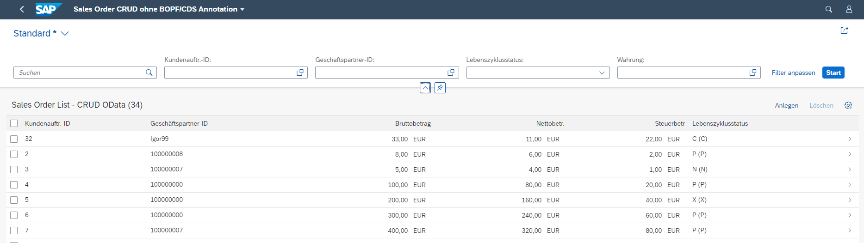

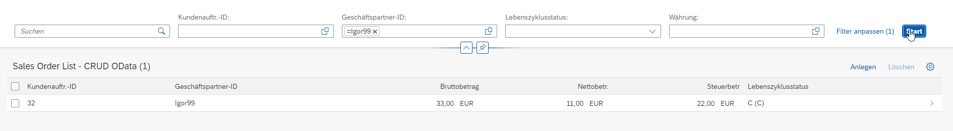



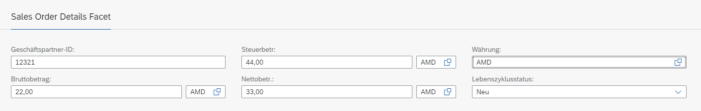



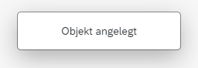

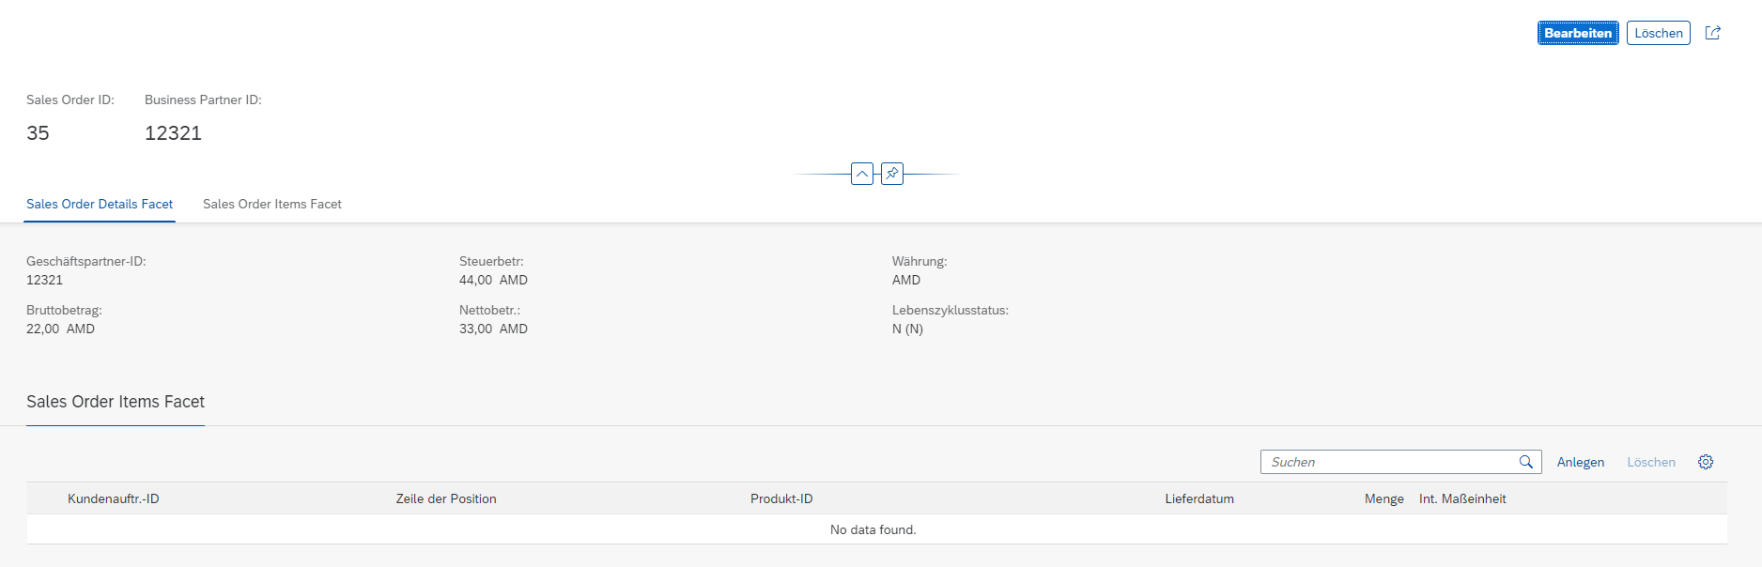

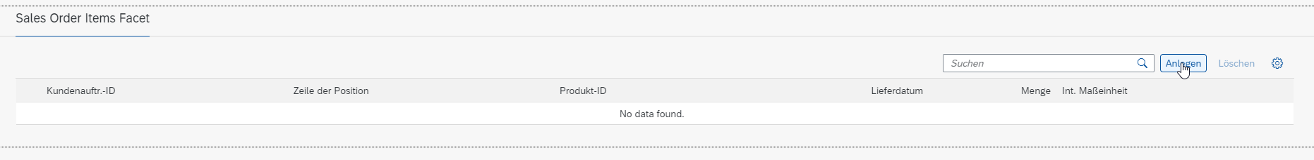

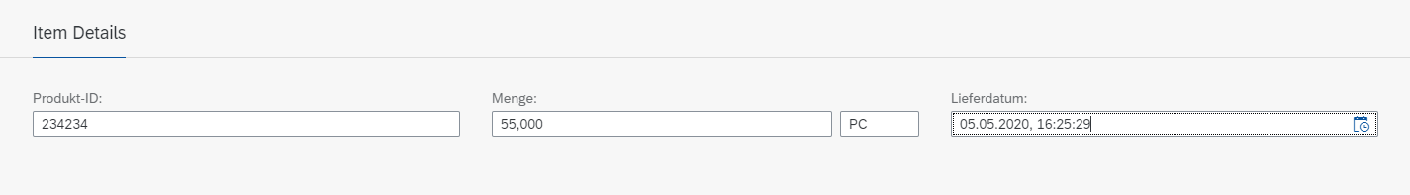



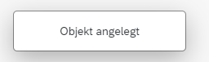



Checking the tables:

